ANA502 Final data preparation

KOHEI NISHITANI

1. Basic Data Understanding

The dataset includes 1287 listings in April 2025 with 41 features.

1.1 Distribution of each columns

1.2 Correlation Matrix

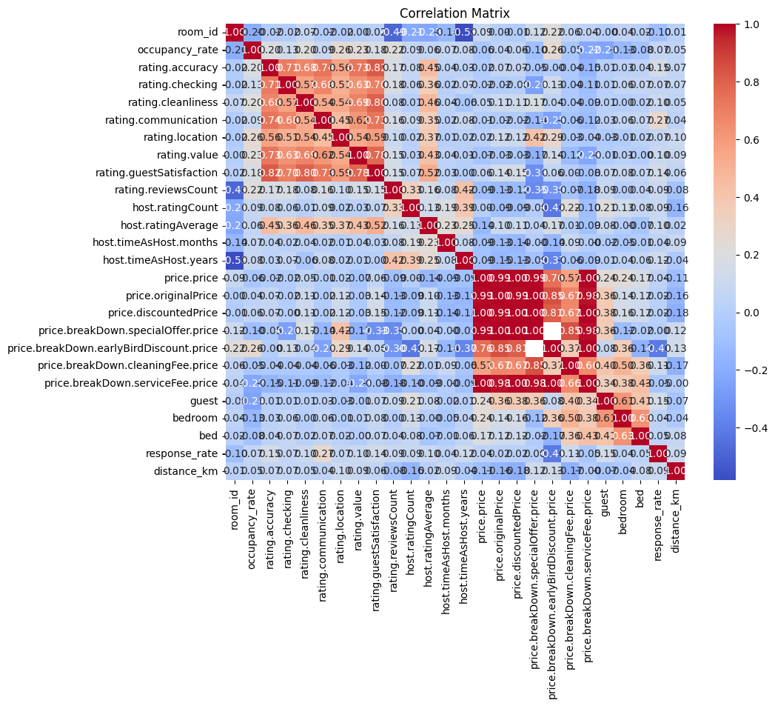

* 1. Occupancy rate(Target variable) distribution

2.1 Highly correlated variable visualization

3.1 Simple Linear Regression

